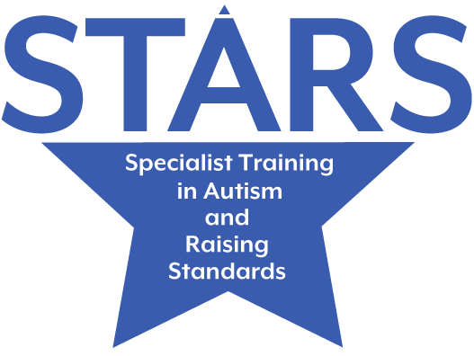

LEAD PRACTITIONERS MEETINGS

The STARS team will lead these meetings and provide: advice, support, training and/or networking opportunities for those staff in a Lead Practitioner, SENCo role or for any member of staff delegated by the school.
Meetings will be held Virtually via /Teams/Zoom and face to face if stipulated
Autumn Term 2023 | Spring Term 2024 | Summer Term 2024
Primary Schools
Date: 26TH September 2023  Time: 4:00 – 5:30pm  Focus: Lead Practitioner networking session | Date: 21st February 2024  Time: 4:00– 5:30pm  Focus: Double Empathy- supporting social understanding and relationships. | Date: 24th April 2024  Time: 4:00– 5:30pm  Focus: Sensory Differences- meeting needs within the classroom.
Secondary Schools & Post 16
Date: 20th September 2023  Time: 4:00 – 5:30pm  Focus: Lead Practitioner networking session | Date: 7th February 2024  Time: 4:00pm -5.30pm  Focus: Supporting CYP to explore their diagnosis | Date: 1st May 2024  Time: 4:00pm - 5.30pm  Focus: Good Autism Practice -What next? Key approaches and strategies.
Please let us know if you would like to attend as early as possible; if you do not book, we will not be able to contact you in case of cancellation. To book your place please refer to www.leedsforlearning.co.uk

